# Project Documentation Phase 9

Event Management & Ticketing System on Salesforce

## Phase 9: Reporting, Dashboards & Security Review – Event Management & Ticketing System

### 🔹 Objective

To build **reports and dashboards** that provide insights into ticket sales, attendee engagement, and event success, while ensuring **data security and compliance**.

### 🔹 Reports

**Go to Reports → New Report → Select Report Type (use your custom objects). Some key reports:**

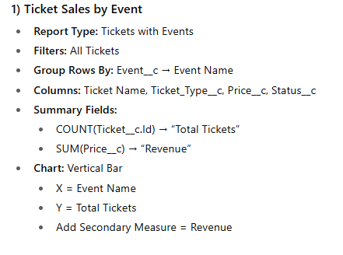

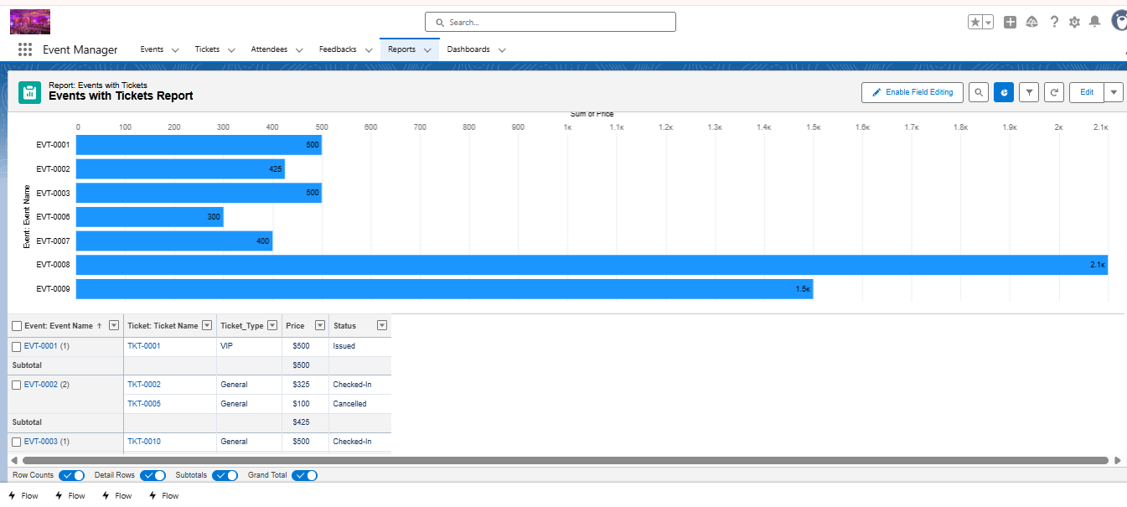

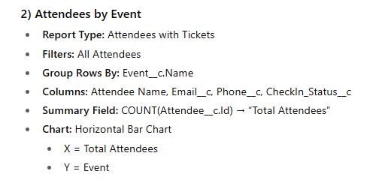

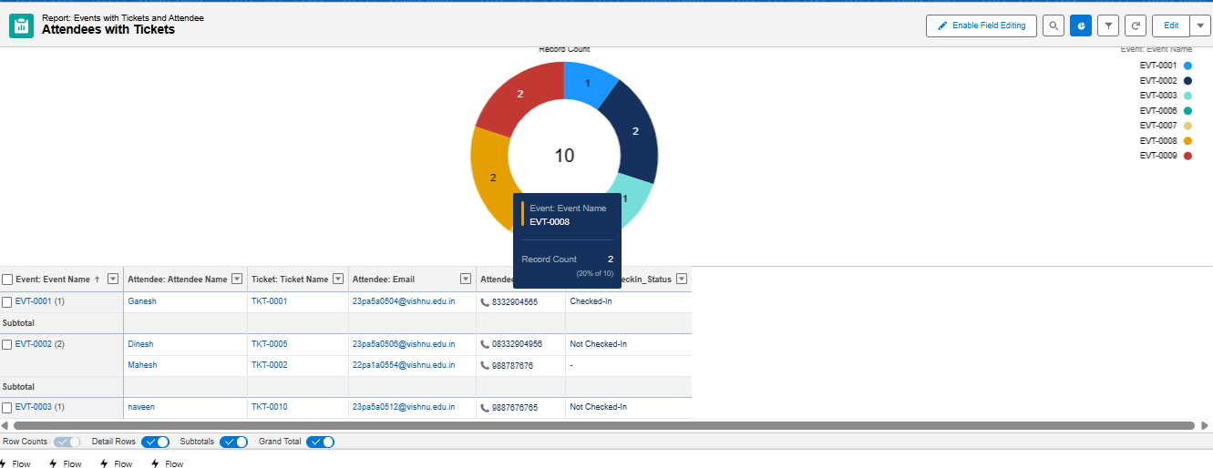

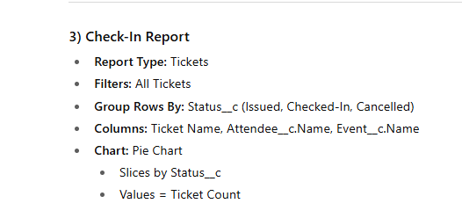

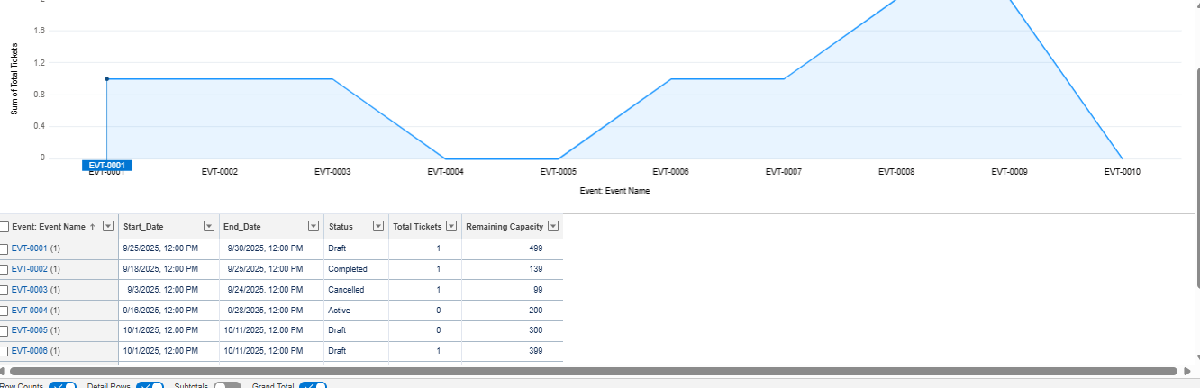

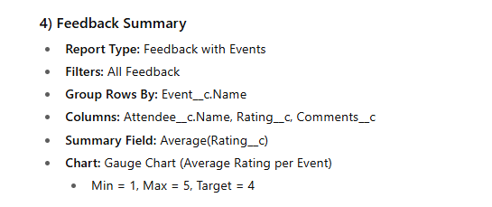

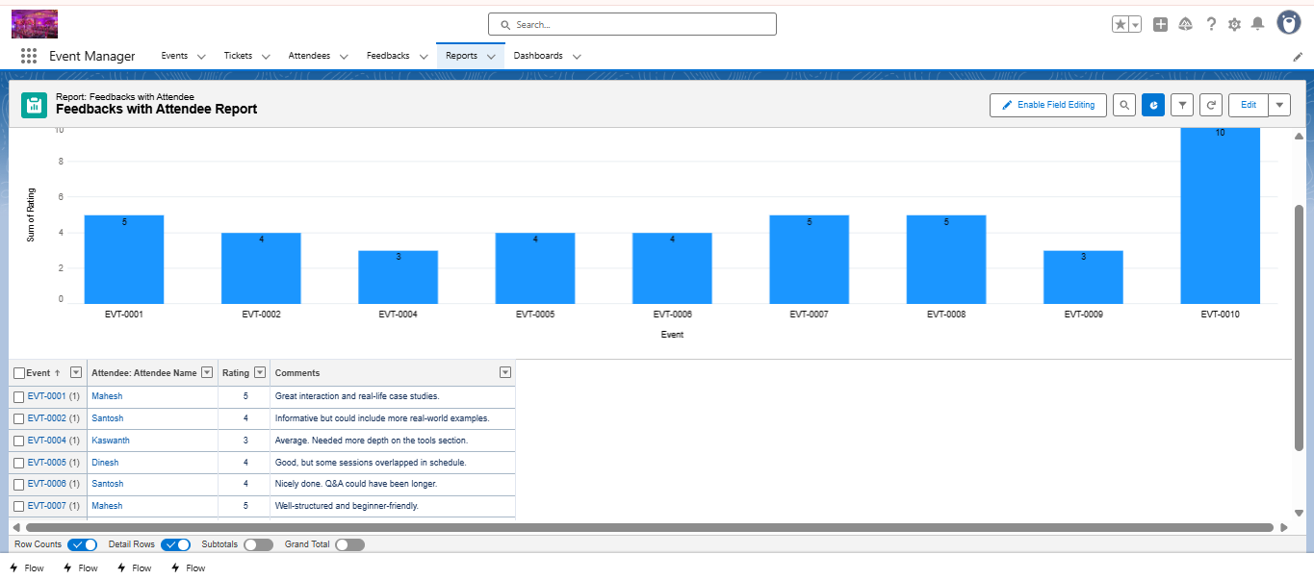

### 

### Dashboards

Dashboards combine multiple reports into visual insights.

**Key Dashboard Components:** 1. **Ticket Sales by Event** (Bar Chart). 2. **Checked-In vs Issued Tickets** (Donut Chart). 3. **Event Feedback Trends** (Line Chart). 4. **Revenue Generated by Event** (Gauge).

* Dashboards scheduled for **daily refresh**.
* Role-based dashboards for **Organizer, Admin, and Attendee views**.

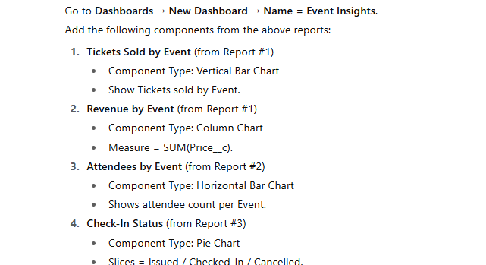

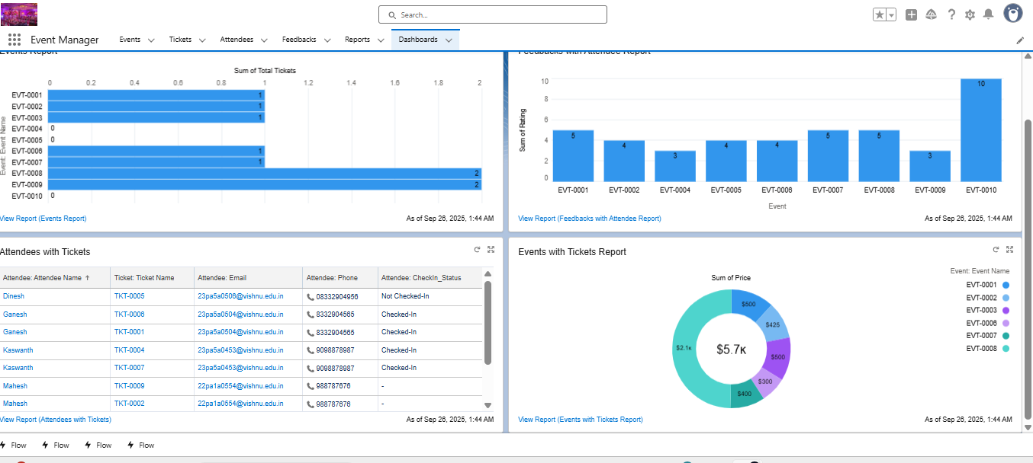

### 🔹 Dynamic Dashboards

* Dashboards run as the logged-in user.
* Organizers → See only their managed events.
* Admin → See all events and tickets.
* Attendee → Limited to their registered tickets.

### 🔹 Outcome of Phase 9

✅ Business insights with real-time dashboards & reports.  
✅ Personalized views with dynamic dashboards.

This completes **Phase 9 (Reporting, Dashboards & Security Review)** for the *Event Management & Ticketing System*. The system is now **data-driven, secure, and deployment-ready**.